Proposal
  - FitPhone



Exulans Team
Fontys University of Applied Sciences
05/09/2025

1. Table of Contents
1. Table of Contents 2
2. Introduction 3
2.1 Project Focus 4
3. Justifications 5
4. Timeline and Planning 5
4.1 Detailed Phasing 6
4.2 Gantt Chart 8
5. Methodology and Delivery Approach 8

2. Introduction
The main goal of this project is to raise awareness among young people and their relationship with their smartphones. While phones have many benefits there is a darker side too and phones are distracting us from important tasks, make us more indecisive and make us have this fear of missing out, they are ruining our sleeping schedule and can be easily trackable which is detrimental to our privacy.
Fitphone is aiming to help young people balance between technology and improve their well–being by combining data science with behavioral insights, this project will help students understand the impact of their phone habits, encouraging healthier smartphone use and better sleep quality.

2.1 Project Focus
Domain Analysis: Our team will focus on the research part to better understand the area of expertise of FitPhone. This step will give us chance to understand the problem better, to meet the user’s needs, to compare with the existing solutions, help us understand what kind of data we need and how can AI analyze it.
With better knowledge of the domain, we can create interventions that are practical, evidence-based, and appealing to students.
Data Collection Searching for smartphone usage logs, sleep diaries, daily time on the phone, and supporting research data
Exploratory Analysis:
- Literature Review: Research about the effects of using smartphones for sleeping schedules, concentration and stress.
- Interviews and surveys: Question our users about how they feel and how smartphones are affecting them.
- App Store Scan: Compare how each existing app for that reason proposes and what we can add to better the situation.
Model Development:
- Historical Data Evaluation:
- Stakeholder Validation:
- Model Evaluation from FitPhone - Opt-in rate, weekly retention, intervention completion rate.
- Students (end-users)

3. Justifications
While phones have many benefits there is a darker side too and phones are distracting us from important tasks, make us more indecisive and make us be afraid of missing out, they are ruining our sleeping schedule and can be easily trackable which is a bad thing if in wrong hands.
Fitphone is aiming to help young people balance between technology and improve their well-being by combining data science with behavioral insights, this project will help students understand the impact of their phone habits, encouraging healthier smartphone use and better sleep quality.

Why are we going to do that:
Smartphone data analysis using AI can raise awareness of digital habits and sleep quality. The project turns basic usage data into personalized feedback to encourage healthy smartphone use by young people.
Student (18–25):
- Raise awareness of how smartphone use affects sleep and well-being.
- Give customised feedback instead of screen-time reports.
- Clear, data-driven insights encourage behaviour change.
For Fitphone/Fontys:
- Look into how AI can improve digital wellbeing in education.
- Confirm the connection between smartphone use and lifestyle outcomes.
- Create a foundation for stress, sleep, and focus prevention programs.

4. Timeline and Planning
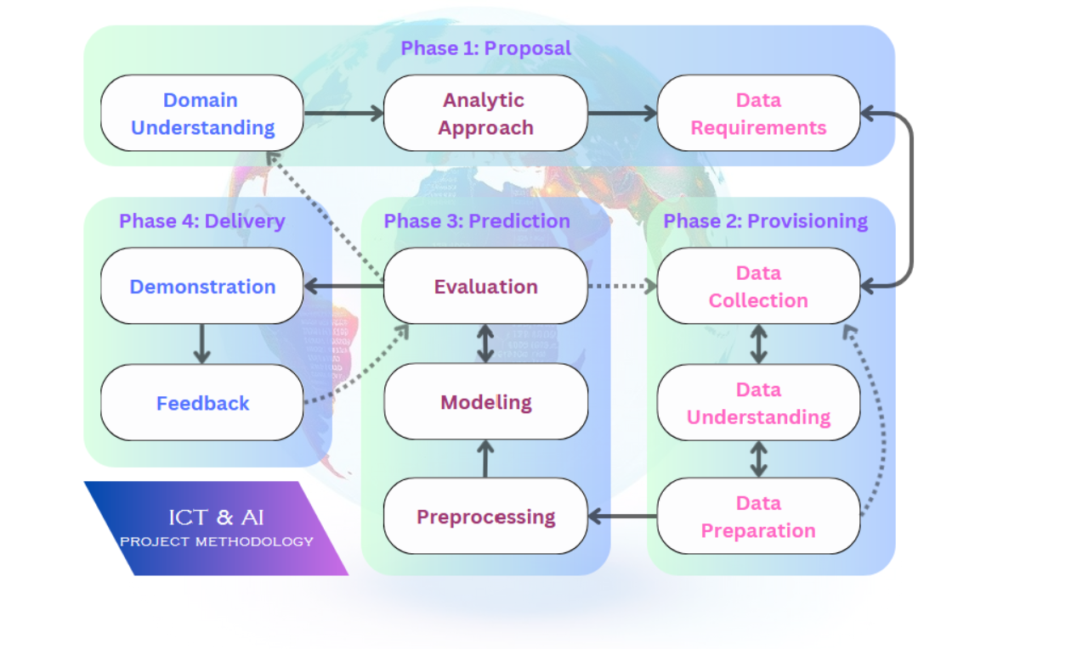
We will use the AI Methodology for our planning.
- Phase 1 is all about understanding the domain we’re working in (in this case people’s behavioral patterns and how that correlates to their sleeping patterns) and setting data requirements.
- Phase 2 is about collecting and understanding the data and preparing it so that the Machine Learning Model can use them to train and improve.
- Phase 3 is about training and testing the model and seeing how it performs.
- Phase 4 is about demonstrating it to the stakeholders and implementing feedback. It is a continuous cycle; each iteration will build on the last one.

4.1 Detailed Phasing
Iteration | Phase | Description | Goals
0 | Week 1-6 | Quickly making an Iteration 0. Going through all the phases quickly. (Understanding the topic of people’s behavior, making sure the data is consistent and ready for use. And using that to make a model. And evaluating the outcomes) | Doing Domain Analysis and collecting data, understanding & preparing and making the model.
1 | Week 7-10 | Evaluating how iteration 0 went, then improving the aspects based on new insights that we gained. (We will use the new insights to improve our expertise. And to improve the model based on that.) | Using the new insights, we gained to improve all the phases and improve the model. We will focus on analyzing and understanding behavioral data and improving the model based on that.
2 | Week 11-14 | Evaluating how iteration 1 is, discussing the aspects that went well and the parts that could be improved. And then looking back and see where things can be improved. And refine it.) | Evaluating and testing and improving the model. If we gain more insights in people’s sleeping patterns and to also improve the data and model etc. Based on the outcome
3 | Week 15-18 | Evaluate the model and improve it further. | Evaluating how the model performs after 3 iterations and sees where It can be improved further. Or where we can add features.

4.2 Gantt Chart
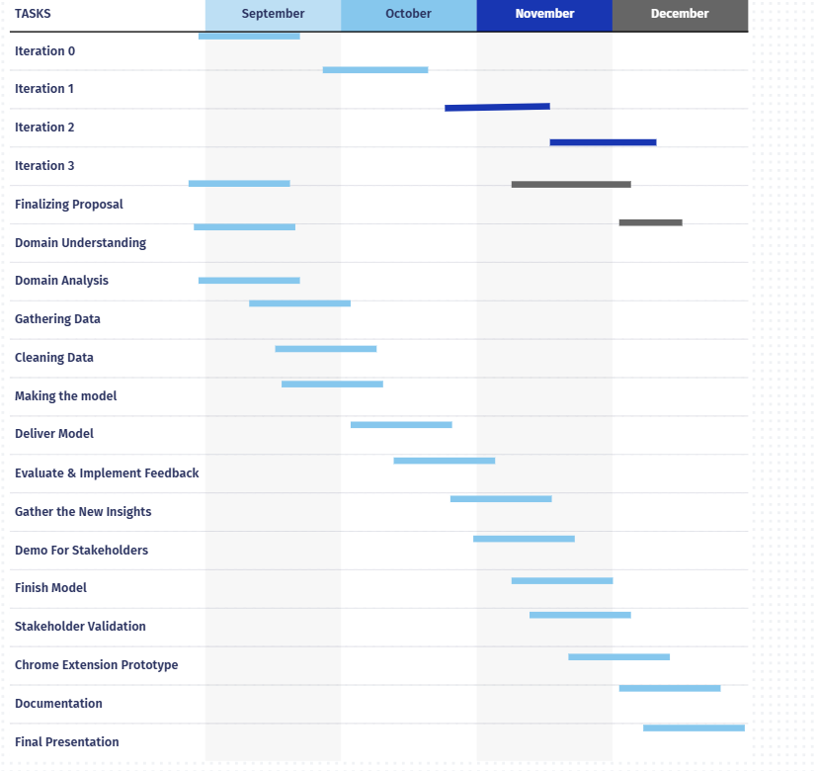

5. Methodology and Delivery Approach
Scrum
- We will implement the scrum methodology in our project. Improving with each sprint is the core of the scrum methodology. We want to improve our results and by evaluating (think of stand-ups and sprint reviews) each sprint we improve continuously which will improve the group dynamics by a vast amount.
- We will start each day with a stand-up. Where each member will talk about what they did the previous day, what they want to do now and if they are stuck somewhere. By doing this everyone has a good idea of what everyone is doing which increases the transparency and if a team member is stuck someone can help them which will improve the team chemistry, but it will also make sure the project doesn’t stop because of communication issues or technical issues.
- After each iteration we will do sprint meetings where we will discuss the things that went will last sprint and we want to keep doing, things that did not go well and we want to get rid of, and things that we want to start doing to improve a certain aspect. Sprint meetings are the moment where each team member can give their experience and their vision on how they want to see things and based on that we can compromise to come up with an evaluation that works for everyone.
Delivery approach
- We will experiment and also implement the model based on the parameters and aspects Fitphone finds most important. That way we can get the best results and solution that FitPhone also had in mind before the project started.
- The documentation will be very precise and well-explained so that it is easily understandable for the stakeholders.
- We will have biweekly meetings with FitPhone and we will use their feedback to implement it into the model to strive for the best version of the model possible.

